# Graph Theory

* Many real-world problems concern objects and relations, e.g. people with friendships, cities connected by highways, web pages linked to others, etc.
* The mathematical abstraction of these situations is the study of graph theory.
* A **graph** is a collection of points and curves.

#### Definition:

* A **graph** G consists of a pair of finite sets:
* A nonempty set of V of **vertices** and a set of E of **edges**, where each edge is associated to a subset of V of either 1 or 2 vertices, called the **endpoints** of the edge.
* An edge with just one endpoint is called a **loop**.
* 2 edges with the same endpoints are called **parallel edges**.
* An edge is said to **connect** its endpoints and be **incident** on each endpoint.
* A vertex on which no edges are incident is called **isolated**.
* 2 vertices connect by an edge are called **adjacent**.

Exercise:

Write down V and E for the following graph. List any loops and parallel edges.

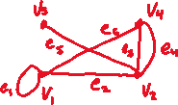

Exercise:

Draw a graph that has 5 vertices include 1 isolated, 1 loop, and 1 pair of parallel edges.



### Definition (Simple Graph):

* A **simple graph** is one that does not have loops nor parallel edges.

Exercise:

Draw a simple graph with $V=\{u, v, w,x\}$ and 2 edges, one of which has endpoints $u$ and $v$.



### Definition (Complete Graph):

* A **complete graph** on $n$ vertices, denoted by $K_{n}$, is a simple graph with $n$ vertices whose edge set contains exactly one edge for every pair of distinct vertices.

Exercise:

Draw .



### Definition (Complete Bipartite Graph):

* A **complete bipartite graph** on $(m, n)$ vertices, denoted by $K_{m_{1},n_{1}}$ is a simple graph with $V=\left\{V_{1},…,V_{m},W_{i},…,W_{n}\right\}$ such that for all $1≤i,k≤m$ and all $1≤j, l≤n$, we have

1. An edge from each $V_{i}$ to each $W_{j}$;
2. No edge from any $V_{i}$ to any other $V_{k}$;
3. No edge from any $W_{j}$ to any other $W_{l}$

Exercise:

Draw .



* A simple graph is **bipartite** if there exists $U⊆V$ and $W⊆V$ such that:

1. $U∪W=V$ and $U∩W=∅$;
2. Every edge connects to a vertex of $U$ with a vertex of $W$.

Exercise:

Which is bipartite?

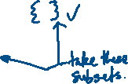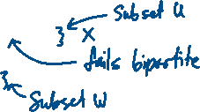

### Definition (subgraph):

* A graph $H$ is a **subgraph** of a graph $G$ if
* Every vertex in $H$ is in $G$;
* Every edge in $H$ is in $G$; and
* Every edge in $H$ has the same endpoints in $G$.

Exercise:

Draw all the subgraphs of

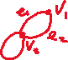

Exercise:

Draw 2 subgraphs containing 2 vertices each, one simple and one not.

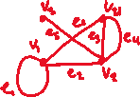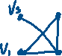

#### Definition (Degree):

* Let $G$ be a graph, $v∈V$.
* The **degree** of $v$, denoted by $δ(v)$, is the number of edges incident on $v$ (with loops counted twice).
* The degree of $G$ is the sum of degrees of all $v∈V$.

Exercise:

Find the degree of $G_{1}$ and .

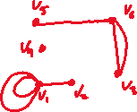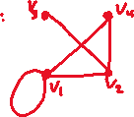

Exercise:

Draw graphs with $\left|V\right|=4$ and vertices of degree:

1. ;



### The Hand Shake Theorem:

* The degree of a graph is twice the number of its edges.
* This holds because each edge always has 2 endpoints.
* So, the degree of a graph is always even, and a graph with 4 vertices of degree 1, 1, 2, 3 is impossible.

### Isomorphic Graphs

Is there any difference between these graphs?

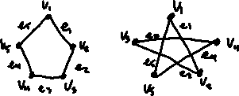

#### Definition:

* Let $G, G^{'}$ be graphs $G=\left(V,E\right), G^{'}(V^{'}, E^{'})$.
* We say $G$ is **isomorphic** to $G^{'}$ if there exist bijective functions $f:V→V^{'}, h:E→E'$ that preserve adjacency, i.e. $V$ is an endpoint of $e⇔f(v)$ is an endpoint of $h(e)$.

Exercise:

Show that $G$ and $G^{'}$ are isomorphic.

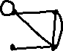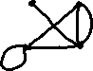

Exercise:

Draw all possible graphs (up to isomorphism) with .



## The Königsberg Bridge Problem

* In 1736, Leonhard Euler introduced graph theory by solving the following problem.



Is it possible for someone to walk in Königsberg, starting and ending at the same point, and crossing each of 7 bridges exactly once?

* This can be translated to a graph: bridges are edges and regions A, B, C, D are vertices.

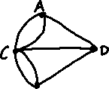

### Walks, Paths, and Circuits

* **Walk:** from vertex $V$ to vertex $W$ in $G$ is a finite alternating sequence of adjacent vertices and edges of $G$ that starts at $V$ and ends at $W$:
$$v_{0}e_{1}v_{1}e_{2}…v_{n-1}e_{n}v_{n}, where v_{o}=v and v_{n}=w$$

* **Length:** of a walk is the number of edges in the sequence.
* If it is not ambiguous, a walk can be denoted by a sequence of only vertices or only edges.
* **Trail:** a walk that does not contain a repeated *edge*.
* **Path:** a trail that does not contain a repeated *vertex*.
* **Circuit:** a walk whose first and last vertices are the same.
* **Simple circuit:** a trail whose first and last vertices are the same.

Exercise:

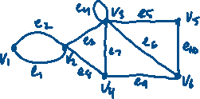

Are the following walks, trails, paths, circuits, or simple circuits?

$v_{1}e_{1}v_{2}e_{3}v_{3}e_{4}v_{3}e_{5}v_{5}$

$e_{1}e_{3}e_{4}e_{4}e_{6}$

$v_{2}v_{3}v_{4}v_{6}$

$v_{2}v_{3}v_{4}v_{2}$

$v_{1}e_{1}v_{2}e_{1}v_{1}$

$v_{1}$

#### Definition (Connected):

* 2 vertices $v,w$ in $G$ are **connected** if there exists a walk from $v$ to $w$.
* $G$ is connected if there is a walk between every pair of vertices.
* Otherwise, $G$ is **disconnected**.

Example:



#### Definition (Connect Component):

* A graph $H$ is a **connected component** of $G$ if:

1. $H$ is a subgraph of $G$
2. $H$ is connected
3. No connected subgraph of $G$ has $H$ as a subgraph and contains vertices or edges that are outside of $H$.

Example:

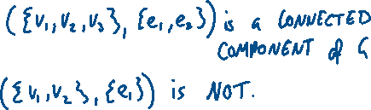

#### Definition (Eulerian Circuit):

* An **Eulerian circuit** of $G$ is a simple circuit that contains every vertex and every edge of $G$.
* If an Eulerian circuit exists, $G$ is an **Eulerian Graph**.
* An **Eulerian path** from $v$ to $w$ is a path from $v$ to $w$ that passes through every vertex in $G$ at least once, and every edge in $G$ exactly once.

### Theorem:

* If $G$ is an Eulerian graph, then every vertex of $G$ has an even degree.
* Equivalently, if some vertex of $G$ has an odd degree, then $G$ is not Eulerian.

#### Proof:

$G$ has an Eulerian Circuit, which uses each edge exactly once. Beginning at vertex $v$, follow the circuit. As the circuit passes through a vertex, it uses 2 edges; one arriving to the vertex and one leaving it. Each edge is used once, so each vertex uses an event number of incident edge endpoints. The starting point $v$ is of even degree as well, since the circuit begins by leaving $v$, then using $v$ an even number of times, then arriving at $v$. $∎$

Exercise:

Does the following have an Eulerian circuit? An Eulerian path?

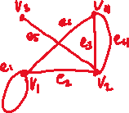

### Euler’s Theorem:

* In a connected graph, the degree of every vertex is even and positive IFF the graph is Eulerian.

## Tree

#### Definition:

* A graph is a **tree** if it is connected and has no circuits.

Example:

Which are trees?

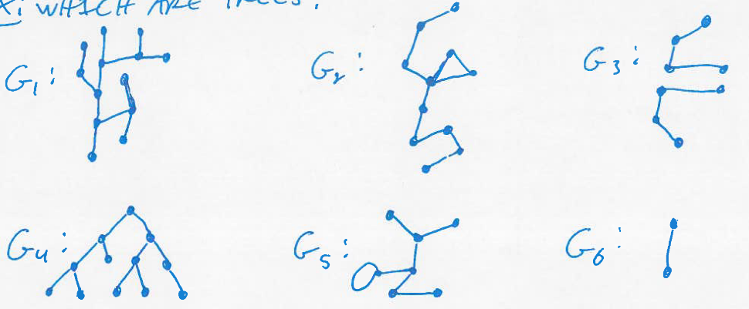



### Theorem:

* For any $n∈N$, a tree with $n$ vertices has $n-1$ edges.

### Theorem:

* For any $n∈N$, if $G$ is connected with $\left|V\right|=n$ and $\left|E\right|=n-1$, then $G$ is a tree.

Exercise:

Draw a tree with 5 vertices and 4 edges. Draw a graph with 5 vertices and 4 edges that is not a tree.



### Definition (Spanning Tree):

* A **spanning tree** of $G$ is a subgraph that contains every vertex of $G$ and is a tree.
* Every connected graph has a spanning tree.
* Any 2 spanning trees for a graph have the same number of edges.

Exercise:

Find all spanning trees.

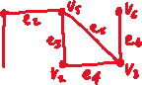

Exercise:

Let the edges represent phone lines, the number represent the cost (in thousands) of installing the lines.

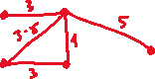

Find the spanning tree and determine the minimum cost.



### Definition (Weighted Graph):

* A **weighted graph** is a graph for which each edge has an associated positive weight.
* The sum of edge weights is the weight of the graph.
* A **minimum spanning tree** for a connected, weighted graph is a spanning tree that has the least possible weight.
* NOTE: minimum spanning trees are not necessarily unique.
* We use $w(e)$ and $w(G)$ for the weights of edge $e$ and graph $G$.

## Kruskal’s Algorithm

* To find a minimum spanning tree, the edges are examined in order of increasing weight.
* At each step, we add an edge to what will be the minimum spanning tree, one does not create a circuit.

Example:

Find a minimum spanning tree.



A: First, put the edges in order by weight.

|  |  |  |  |  |
| --- | --- | --- | --- | --- |
| Edge | Weight | Will adding edge make a circuit? | Action | Cumulative Weight |
|  |  |  |  |  |
|  |  |  |  |  |
|  |  |  |  |  |
|  |  |  |  |  |
|  |  |  |  |  |
|  |  |  |  |  |
|  |  |  |  |  |
|  |  |  |  |  |

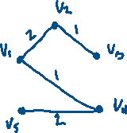

Exercise:

Find a minimum spanning tree.

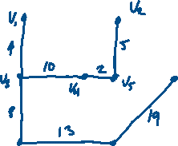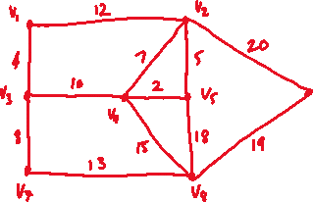

|  |  |  |  |  |
| --- | --- | --- | --- | --- |
| Edge | Weight | Circuit? | Action | Cumulative Weight |
|  |  |  |  |  |
|  |  |  |  |  |
|  |  |  |  |  |
|  |  |  |  |  |
|  |  |  |  |  |
|  |  |  |  |  |
|  |  |  |  |  |
|  |  |  |  |  |
|  |  |  |  |  |
|  |  |  |  |  |
|  |  |  |  |  |
|  |  |  |  |  |



## Prim’s Algorithm

* Build a minimum spanning tree by choosing a vertex and expanding outwards adding one edge and one vertex at each step.

Example:

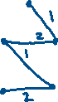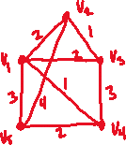

A: Start with (arbitrarily) $V_{1}$.

|  |  |  |  |
| --- | --- | --- | --- |
| Vertex Added | Edge Added | Weight | Cumulative Weight |
|  |  |  |  |
|  |  |  |  |
|  |  |  |  |
|  |  |  |  |

Exercise:

Find the MST with Prim’s algorithm.

